This date was in marsh soil category, however, the dominant species are *Pinus elliottii, Pinus clausa, Quercus virginiana, Nyssa aquatic.* After double checking with the PDF, the system type was ‘Forested Wetland’, confirmed by Meng

1. The soil C pool data was from Table 3 63.3 kg m-2 for soil depth of 90 cm.

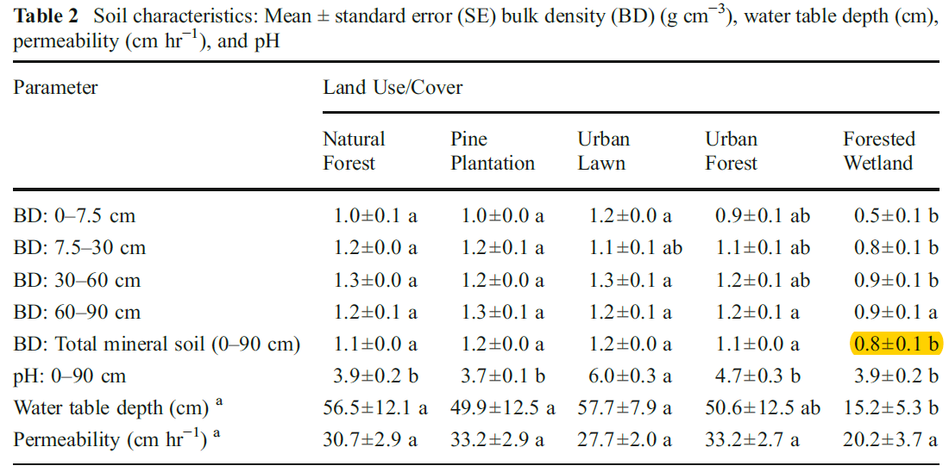

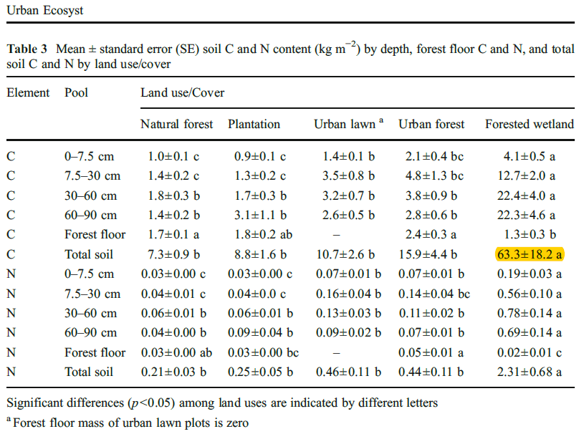

2. The aboveground biomass rate was from Table 5.

